Importing Nodes into CheckMK

Author: Jeremiah Holland

Date: 10/24/2025

Version: 1.0

To add hosts into CheckMK for monitoring.

Revision History 3

Pre-Reqs 4

Required Documentation 5

Install Agent on CheckMK Server via GUI 6

Download the Agent 7

Install the Agent via yum install 7

Add the CheckMK Server as a host to Monitor 8

Configure and Scan a Host 9

Determine which resources should be monitored 9

Confirm Changes 10

Reviewing a Monitor 12

Installing the agent on remove server 13

Use SCP to transfer agent file to remote host 14

Open Firewall Port on Remote server 14

Install software on remote server 15

Add Remote server as a Host to Monitor 16

Select Services and Resources to Monitor 17

Confirm the Changes 18

# Revision History

|  |  |  |
| --- | --- | --- |
| Date | Author | Update |
| 10/24/2025 | Jeremiah Holland | Initial Draft |
|  |  |  |
|  |  |  |
|  |  |  |
|  |  |  |
|  |  |  |
|  |  |  |

# Pre-Reqs

1. Successfully installed and configured CheckMK
2. Admin access to CheckMK Web Console
3. Hosts must have CheckMK Agent, SNMP, or an API Integration prepared.

# Required Documentation

1. <https://youtu.be/opO-SOgOJ1I>

# Install Agent on CheckMK Server via GUI

* Setup -> Agents -> Select Packaged Agent to Install
* .rpm for Red Hat

## Download the Agent

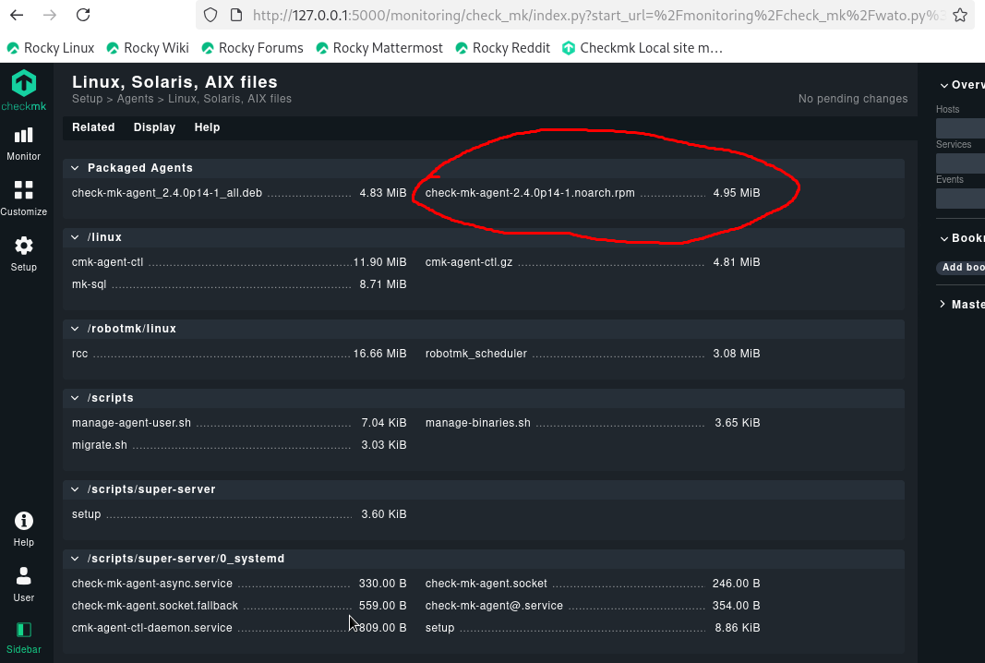

By clicking on the link of the desired package, a download will start to downlaod the agent. 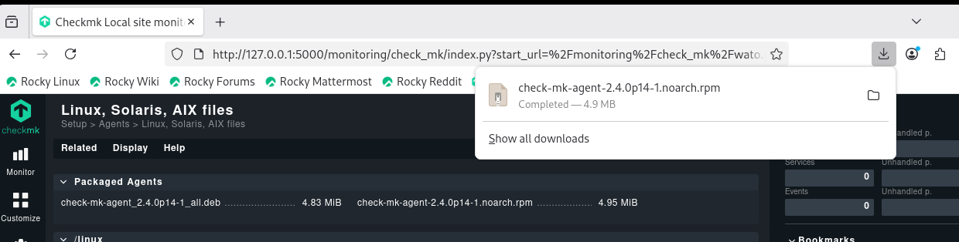

## Install the Agent via yum install

root@linux# sudo yum install <filepath>/<agent_package>.rpm

Verify everything looks correct and press y.

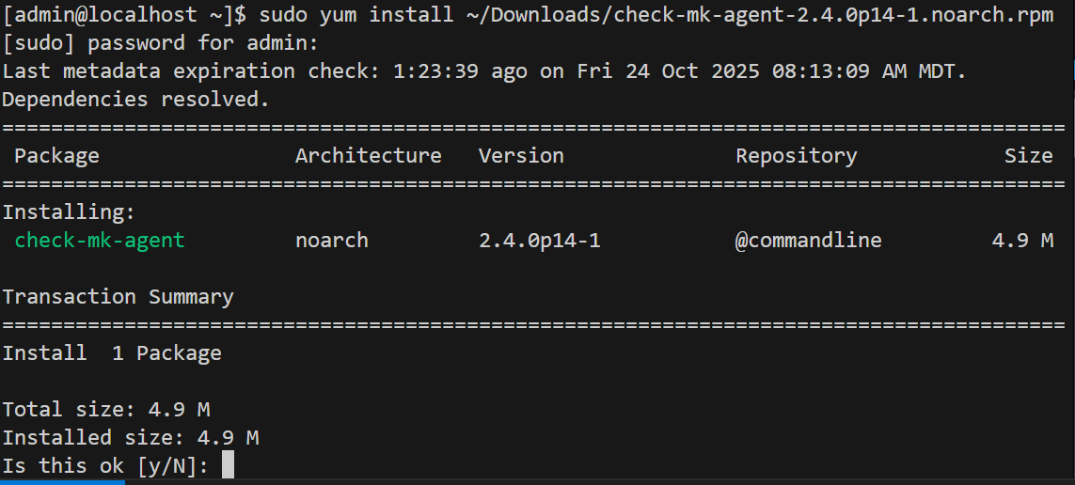

The Installer will run and present any errors and the status of the install.

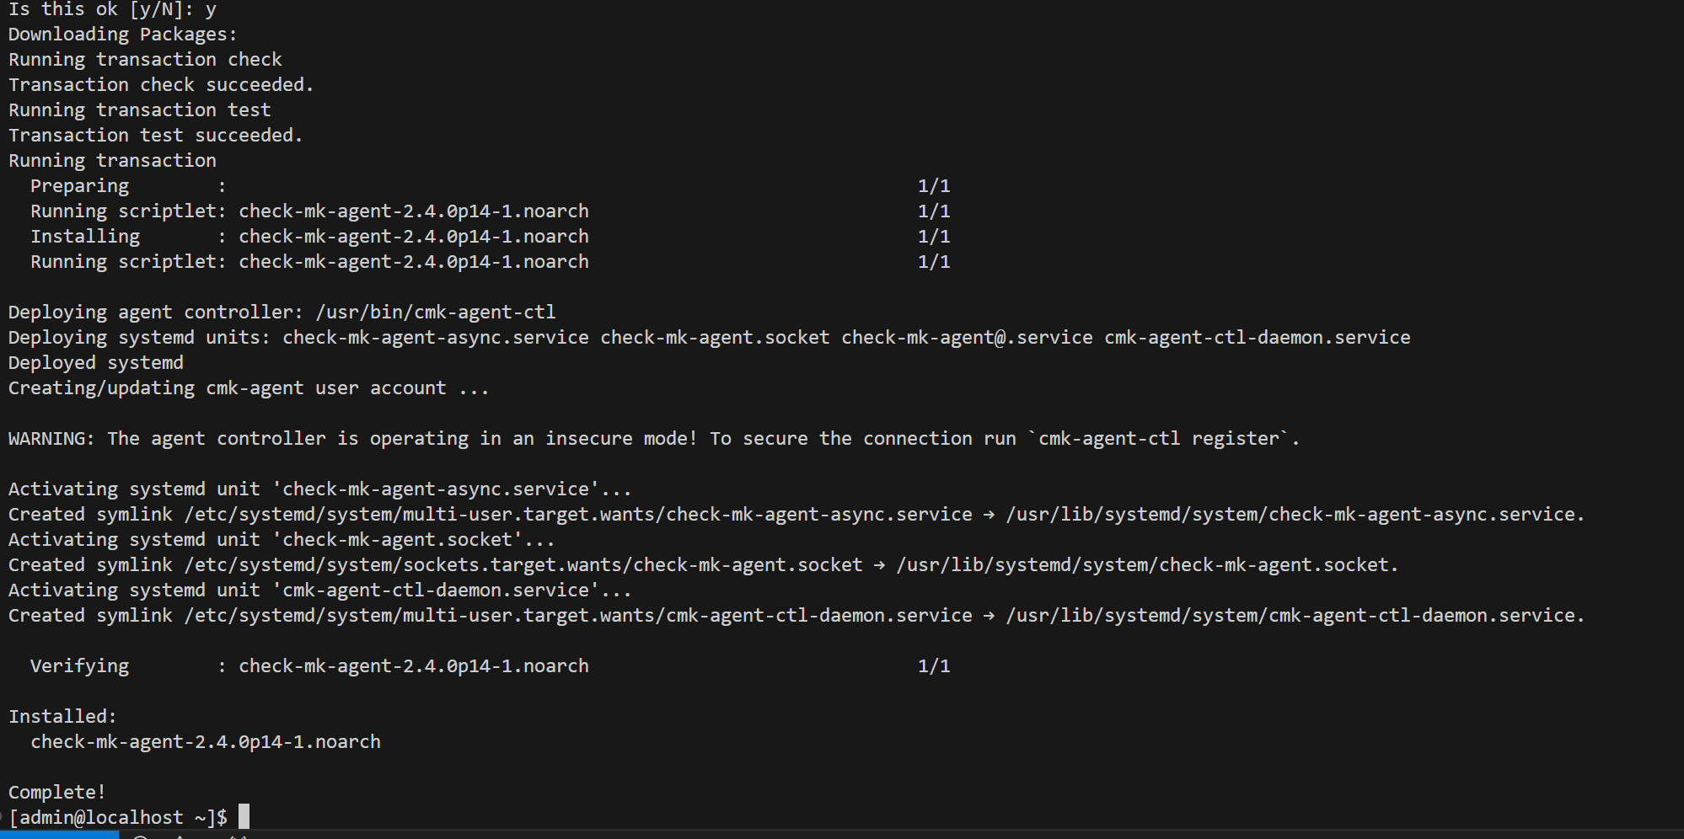

# Add the CheckMK Server as a host to Monitor

## Configure and Scan a Host

Setup -> Host -> Add Host

1. Needs Hostname (can name it whatever)
2. IP address
3. Save & run service discovery

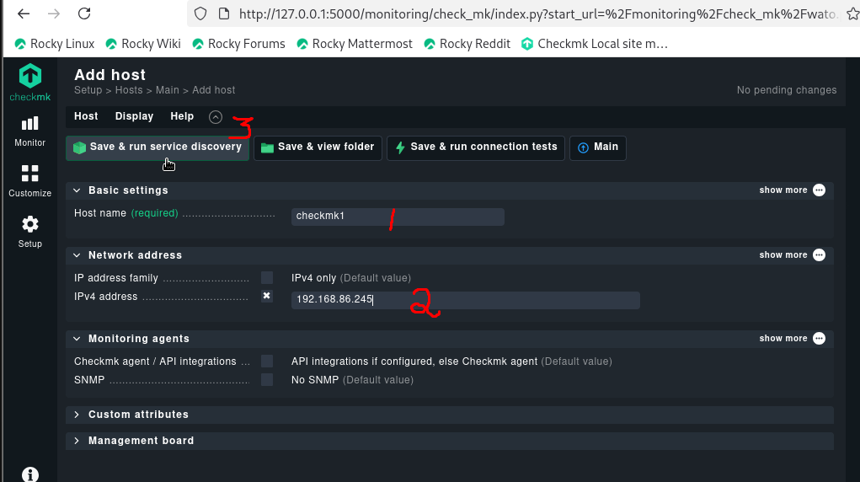

## Determine which resources should be monitored

Can change what gets monitored by selecting or de-selecting a resource that showed up. by default, accept all will bring everything discovered in.

Select Accept all if everything is ok, or choose to remove some services and accept what is selected.

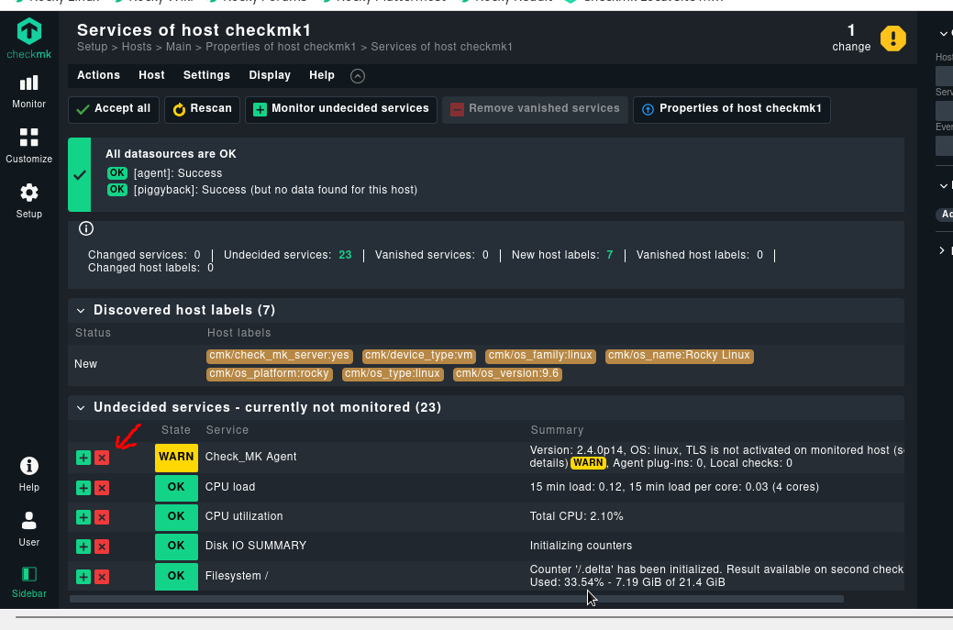

## Confirm Changes

To apply the monitors, select the Changes button in the upper right of the screen.

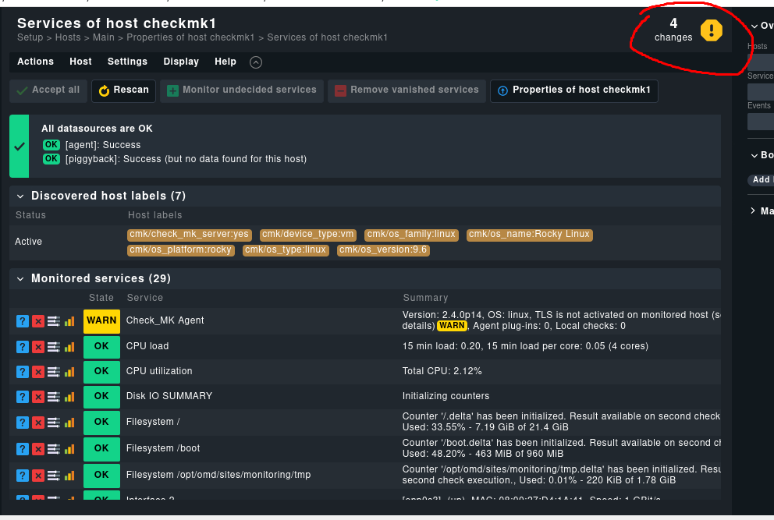

Select Active on Selected Sites

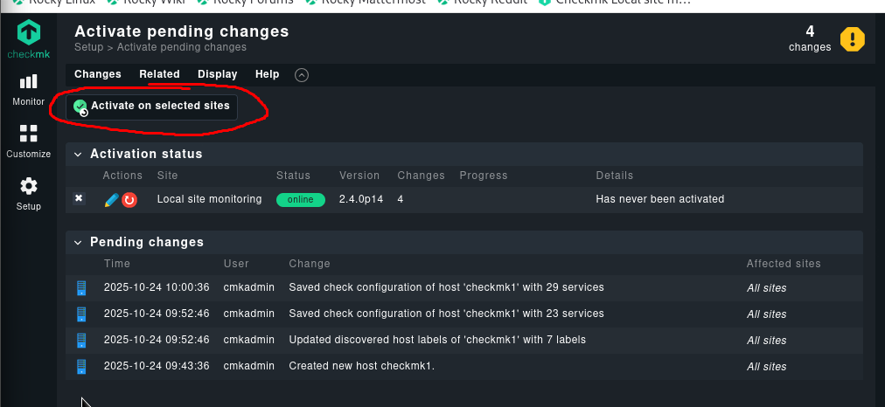

Once Activated, resources will appear on Dashboards.

# Reviewing a Monitor

Go to Monitor -> Overview -> Main Dashboard

The Overview pane on the right will show how mayn hosts and services are being monitored and the dashboard will present an overall view of the environment as well as any problems or concerning events.

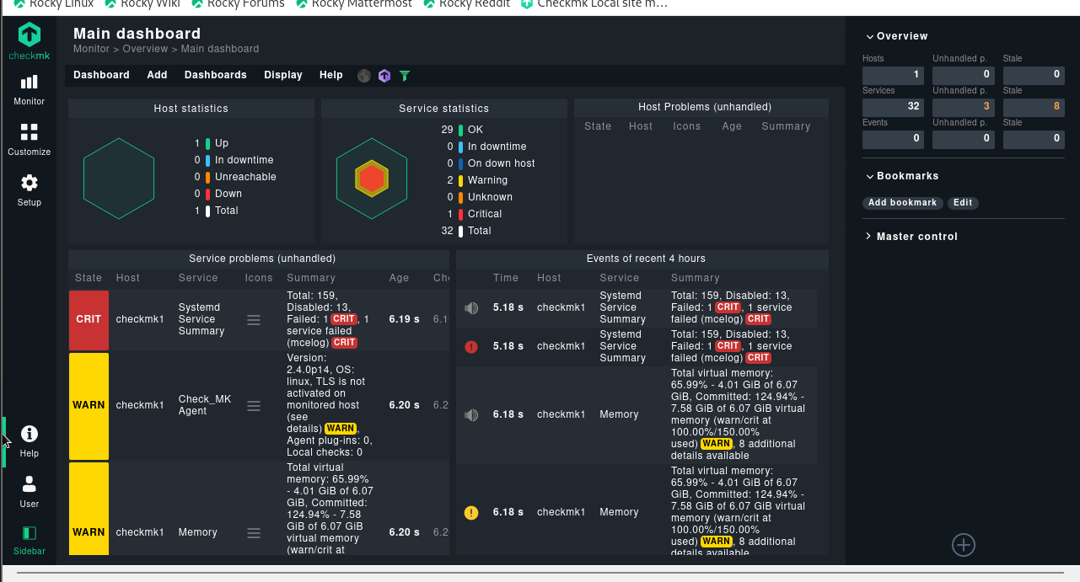

# Installing the agent on remove server

## Use SCP to transfer agent file to remote host

On CheckMK server:

#scp <agent_filepath>/<agent_name> linuxUsername@Host:<Location to save file>

Root@linux# scp /home/admin/Downloads/check-mk-agent-2.4.0p14-1.noarch.rpm admin@192.168.86.23:/home/admin/Downloads

Go to Linux and use Yum to Install Agent.

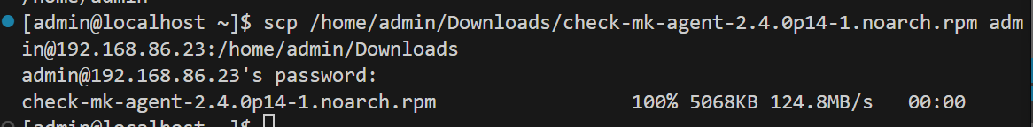

On Remote Server:

Verify that the software is on the remote server.

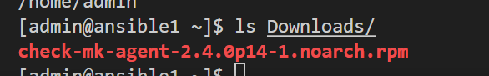

## Open Firewall Port on Remote server

By default, the port TCP/6556 is required to be opened on the Remote server.

Root@remotelinux# sudo firewall-cmd --add-port=6556/tcp --permanent

Root@remotelinux# sudo firewall-cmd –reload

## Install software on remote server

Use Yum to install software on remote server.

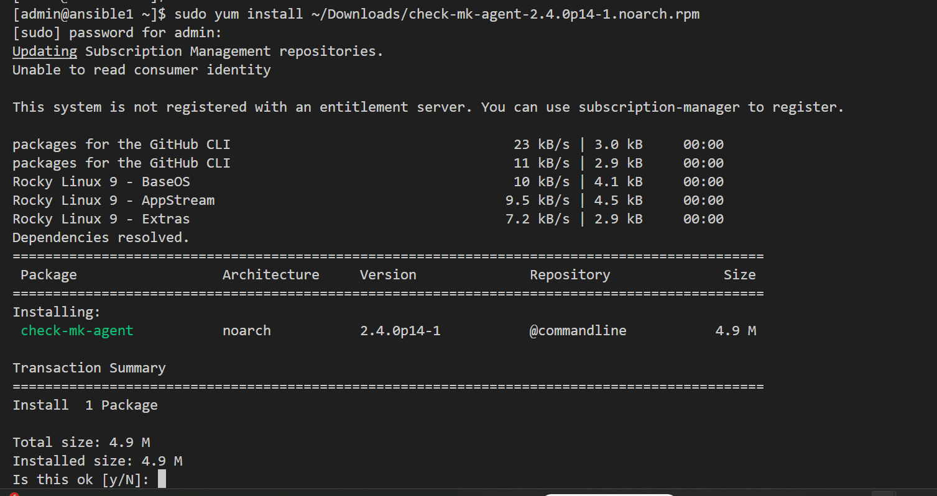

Verify the software installed successfully.

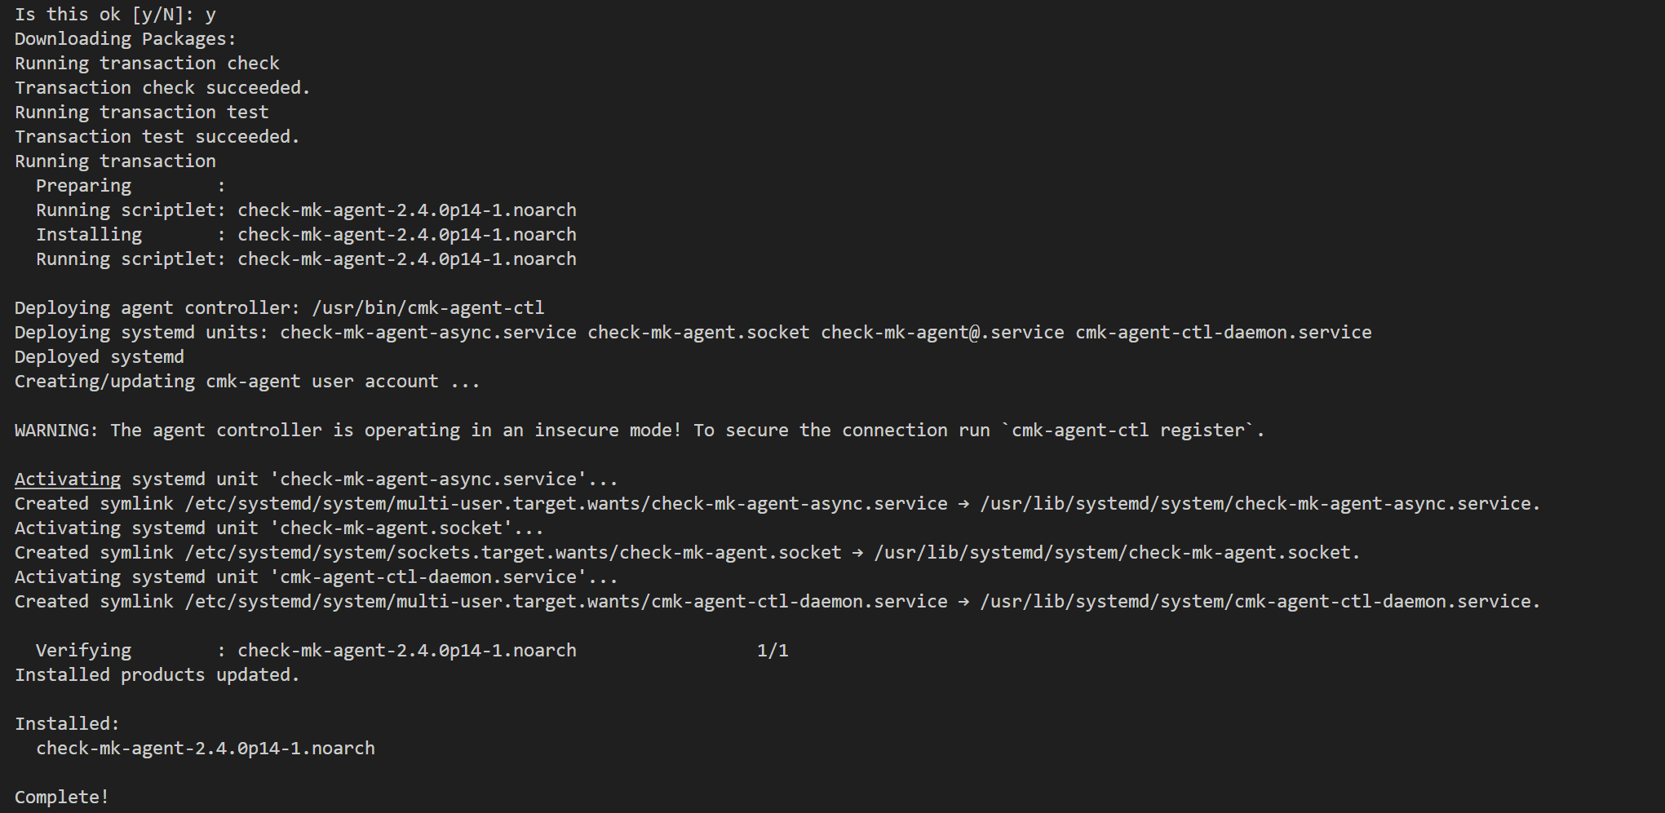

# Add Remote server as a Host to Monitor

Setup -> Hosts -> Add Host

1. Host name (does not have to match hostname of server)
2. IP Address of the Server
3. Save and Run service discovery

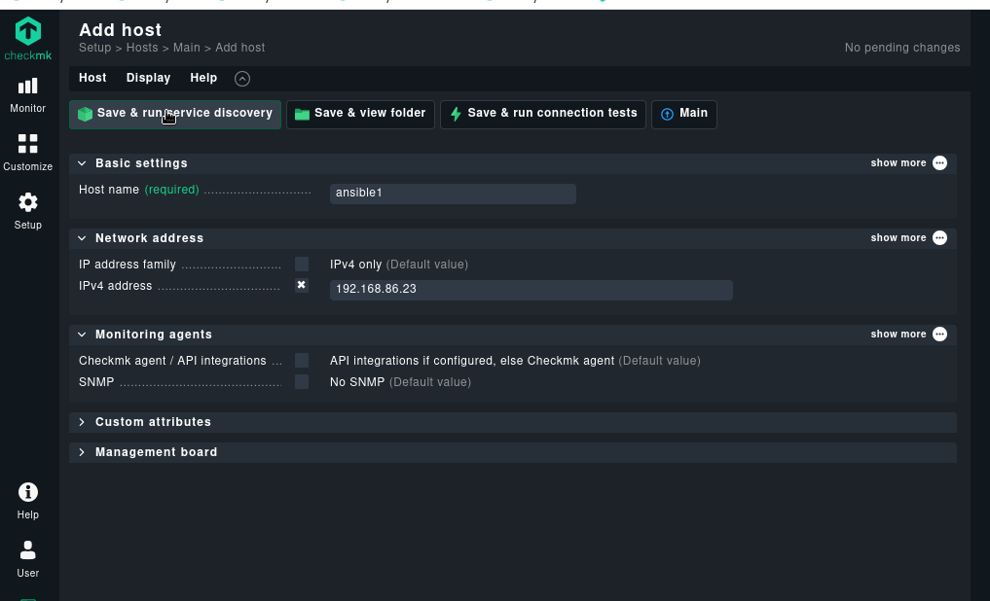

If errors in detecting resources ensure that:

* Network path exists
* Firewall port on remote host is open.

## Select Services and Resources to Monitor

Specific services can be removed, but the defaults can be chosen by selecting Accept All.

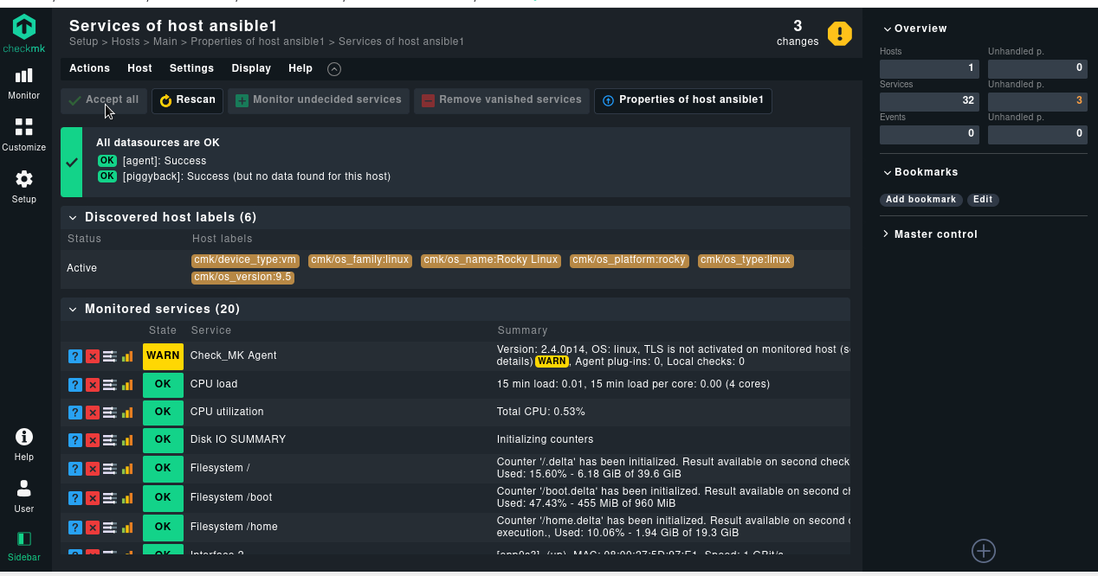

## Confirm the Changes

Select the Changes ! Button

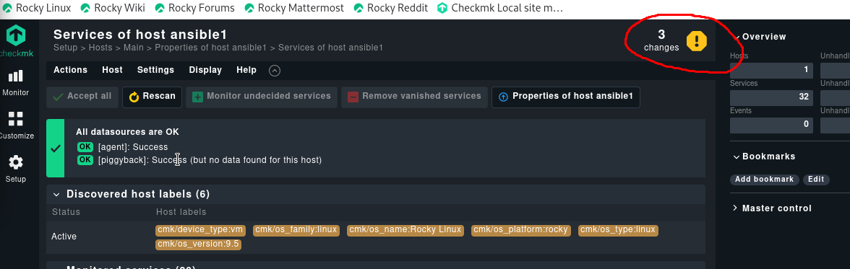

Select the Activate on selected sites button

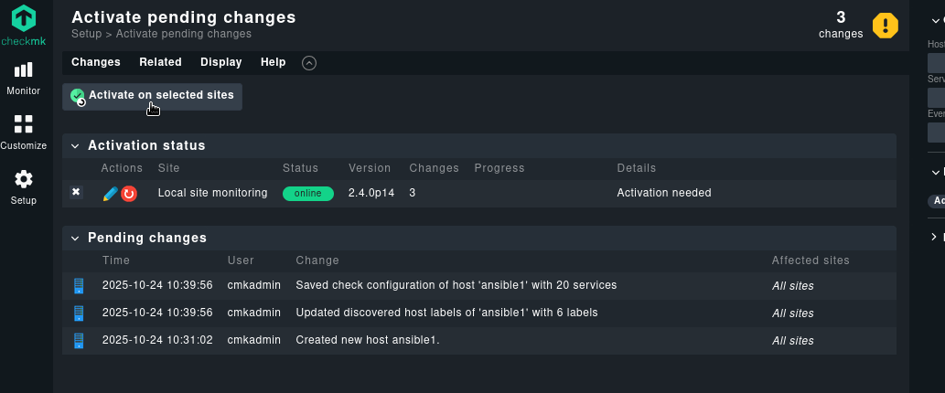

The Progress bar should show Success and this host is now being monitored.

